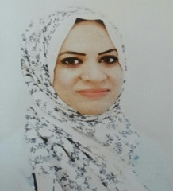
zahraa jawad kadhim
zahraa.jawad@muc.edu.iq

https://scholar.google.com/citations?user=ImNdYecAAAAJ&hl=en

Msc in Mathematics and Computer Applications, Al- Nahrain University College, Iraq.

Lecturer IN al-Mansour University College, Department of Computer Engineering, as well as, member of the exam committee, Projects Committee, social committee, and educational guidance.

experience

- dates from 2010 – 2011
External lecturere, al-Mansour University College, Department of Software Engineering and Information technology

- dates from 2011 – till now
instructor, al-Mansour University College, Department of Software Engineering and Information technology (Currently, Department of Computer Engineering)

- dates from 2015 – till now
lecturere, al-Mansour University College, Department of Computer Science and Information Systems.

education

April - 2009
Msc in Mathematics and Computer Applications, al-nahrain university, Iraq
Thesis Title (G-Spline Interpolation for Approximating the Solution of the Ordinary Differential Equations Using Linear Multistep Methods).

septamber - 2005
bsc in Mathematics and Computer Applications, al-nahrain university, iraq

skills
- get- Connected
- Ms. Dos.
- Microsoft window.
- Microsoft office (word, excel, power point).
- Programming in C, C++, Pascal, and Mathcad, visual FoxPro, MatLab.

Publications
Oscillation Properties for Boundary‐ value Problems with Spectral Parameter in Two‐Point Boundary Conditions. 43, 479‐490

Awards, thanks & appreciation, and patents if any

