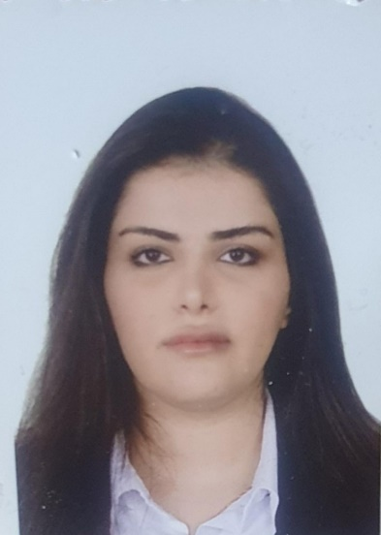

**Name: Nada Eissa Beshet Radhi Al _eqaby**

**Date of Birth: 24_3_1991**

**Phone number :07739680402**

**Email:issanada28@gmail.com**

**Address: Baghdad,Zayona**

**Education: Bachelor in Translation from Alma’mon university college 2014, Master degree : Methods of Teaching English from Almustafa university College 2018**

**Training Courses and workshops : The Art of Etiquette and English terms in the ministry of financial**

**Profissional Experience: worked as lecturer (2020,2021)at Ibn Rushud university (English department) ,Al Bani University College (2022,2023) and Almansoor Univirsity**